INFO 5707 – Data Modeling
Design Phase Report
Learning Management System (LMS) Database
Prof. Sahara Ali

Group 18
Divyasree Pithani (Team Coordinator)
Teja Sai Srinivas Kunisetty
Keerthi Yeakambaram

Date: November 4, 2025

Contents
1. Individual Student Contributions 3
2. Database Objectives and Scope (Revised) 3
3. User Requirements (Revised) 5
4. Business Rules 7
5. Entity-Relationship Diagram (ERD) 8
6. Data Dictionary 11
7. AI Use Disclosure Statement 23

1. Individual Student Contributions
Divyasree Pithani (Team Coordinator)
- Managed the redefinition of database goals and scopes.
- Formulated 4 business rules of enrollment and course administration.
- Designed the first structure of Entity-Relationship Diagram.
- Organized group meetings and on-time delivery of deliverables.
Teja Sai Srinivas Kunisetty
- Reduced user requirements with regard to assessment and grading features.
- Provided 3 business rules in assignment and quiz management.
- Standardized the data dictionaries of fundamental academic entities.
- Helped with ERD relationship definitions and cardinality specifications.

Keerthi Yeakambaram
- Improved user demands for security and access management
- Outlined three business rules concerning user roles and data integrity
- Finalized the data dictionary documentation for user and security entities
- Ensured the ERD aligns with business rules for consistency

2. Database Objectives and Scope (Revised)
Vision
Our goal is to develop a robust, enterprise-level relational database system that acts as the essential data layer for managing online learning platforms. This system will enable educational institutions to effectively oversee, monitor, and evaluate every facet of digital education delivery.
Mission
Design and implement a normalized, scalable database architecture that guarantees data integrity, supports simultaneous multi-user access, maintains detailed academic records, and ensures smooth collaboration among students, instructors, and administrators throughout the process.
Primary Objectives
Objective 1: Unified Academic Data Management Establish a single authoritative source for all academic information, about course catalogs, enrollment details, curriculum frameworks, and academic performance metrics over various terms and academic years.
Objective 2: User Identity and Access Management Develop a strong user management system that facilitates role-based access control for students, instructors, teaching assistants, and administrators, ensuring appropriate data security and privacy measures.
Objective 3: Course Content and Curriculum Organization Facilitate the organized arrangement of course materials, learning modules, and instructional content, with provisions for prerequisites, course sequencing, and curriculum pathways.
Objective 4: Assessment and Evaluation Tracking Keep detailed records of all assessments, including assignments, quizzes, exams, submissions, grading history, and performance analytics, with complete audit trails.
Objective 5: Enrollment and Registration Processing Facilitate comprehensive student enrollment processes, including course registration, waitlist management, enrollment capacity enforcement, and prerequisite validation.
Objective 6: Grade Management and Academic Records Manage, store, and monitor student grades, supporting weighted grading systems, grade distributions, cumulative performance metrics, and transcript generation.

Scope Definition
Organization Type: Educational institutions including universities, colleges, community colleges, corporate training centers, and online education platforms.
Functional Coverage:
- Academic administration and institutional management
- Course catalog and curriculum management
- Student information and enrollment systems
- Instructor assignment and course scheduling
- Assessment creation, submission, and grading
- Performance tracking and academic analytics
- User authentication and authorization
Database Scope Level: Enterprise-level system covering institution-wide online learning operations
Key Functional Areas:
- User management and role-based security
- Course and curriculum administration
- Enrollment and registration processing
- Content organization and module structuring
- Assignment and quiz management
- Submission tracking and version control
- Grading workflows and grade calculation
- Academic reporting and analytics
- Term/semester data organization
Out of Scope:
- User interface design and web application development
- API implementation and endpoint definitions
- Payment processing and financial transactions
- Email notification systems
- Video streaming infrastructure
- Third-party integration specifications
- Mobile application development

3. User Requirements (Revised)

UR-1: Student Enrollment Management The database will handle and store records of student enrollments for courses, including details such as enrollment dates, status (active, dropped, completed), and validation of enrollment capacity to avoid over-enrollment in courses.

UR-2: Course Structure and Organization The database will keep course details, including course codes, titles, descriptions, credit hours, department affiliations, and prerequisite links to aid in curriculum planning.

UR-3: Multi-Term Academic Calendar Support The database will accommodate multiple academic terms or semesters with unique start and end dates, enabling courses to be offered in various terms while preserving historical academic records.

UR-4: Assignment Lifecycle Management The database will monitor the entire lifecycle of assignments, from creation to assignment to courses, student submissions with timestamps and grading status.

UR-5: Quiz and Assessment Administration The database will store quiz definitions, question banks with various question types (multiple choice, true/false, essay, file upload), student responses, and automated scoring for objective question types.

UR-6: Comprehensive Grading System The database will compute and store grades for individual assessments, support weighted grading categories (assignments, quizzes, exams), and calculate final course grades based on configurable grading schemes.

UR-7: Role-Based Access Control The database will implement role-based security, allowing students to access only their enrolled courses and submissions, instructors to manage only their assigned courses, and administrators to have system-wide access for reporting and management.

UR-8: Course Material Organization The database will arrange course materials into modules and topics with defined sequencing, supporting multimedia content references and maintaining links between materials and specific course offerings.

UR-9: Instructor Assignment and Management The database will track instructor assignments to courses, support multiple instructors per course, and maintain teaching assistant associations with specific course sections or roles.

UR-10: Historical Academic Performance Tracking The database will preserve complete historical records of student academic performance, including all submissions, grades, enrollment history, and course completions, to support transcript generation and academic advising.

UR-11: Deadline and Late Submission Tracking The database will store assignment and quiz due dates, track submission timestamps, and identify late submissions to support late penalty calculations and deadline enforcement.

UR-12: Grade Distribution Analytics The database will facilitate queries for grade distribution analysis, including class averages, grade curves, performance comparisons across sections, and historical trend analysis for institutional reporting.

4. Business Rules
BR-1: Enrollment Capacity Enforcement.
Every course being offered should have a set limit for enrolment. Students are not allowed to enroll in a course section when the number of enrolments goes above the maximum capacity unless it is administratively overridden.
BR-2: Prerequisite Validation
A student can qualify to take a course only when he has passed all the prerequisite courses with a passing grade (grade ≥ D or as per the institution) or administrative permission to skip prerequisites.
BR-3: Special Student Admission.
Enrolment into a certain course can only be made by a student once in a term. The system should not allow an over-enrollment of the same course section in the same academic term.
BR-4 Instructor Course Essay.
All the courses provided should contain at least one tutor in charge of the course. Without an instructor assignment, a course cannot become active so that it can be enrolled by students.
BR-5: Deadline for Submission.
All assignments and quizzes should have a certain deadline and time. Students may post work later than the deadline, the system should indicate that it is late and the delay period should be logged.
BR-6: Grade Value Constraints
All marks should be in good ranges: marks in individual assignments/quizzes (or points in maximum points) should range between 0-100 (or 0 to maximum points indicated) and final mark should be out of the institutional grade scale (A, A-, B+, B, B-, C+, C, D, F, or equivalent).
BR-7: Submission Versioning
In cases where a student makes several submissions of an assignment before the due date, only the system should save all the submissions including timestamps. The last submission before the deadline is taken to be the official submission to be graded unless the instructor specifies differently.
BR-8: Grade Calculation Integrity.
The computation of final course grades should be done using graded assessments in the course offering. Calculation should be done according to the weighting scheme set by the instructor and all weights of the categories should not exceed 100%.
BR-9: Role Assignment Rules
Users should be given at least one role (Student, Instructor, Teaching Assistant or Administrator). Multiple roles can be assigned to users (e.g. a graduate student is also a teaching assistant).
BR-10: Term Association of Course Offering.
Courses of study should have only one academic term. Courses cannot be offered in more than one term; individual offerings will have to be made for courses taught in different terms.
BR-11: Assessment Ownership
The quizzes (assignments and tests) should be produced by and be in a particular course offering. Assessment types cannot stand alone and will be deleted in case the parent course offering is deleted.
BR-12: Transition of Enrollment Status.
The enrollment status of students should be made in accordance with legitimate transitions between the states: Pending-> Enrolled-> (Completed OR Dropped OR Withdrawn). Dropped/Withdrawn students are unable to move to Enrolled without establishing a new record of enrollment.

5. Entity-Relationship Diagram (ERD)
ERD Description
The LMS database consists of 12 core entities organized around academic operations:
Core Academic Entities:
- User: Stores all system users (students, instructors, administrators)
- Course: Defines course catalog entries
- Term: Represents academic terms/semesters
- CourseOffering: Links courses to specific terms with instructors
- Enrollment: Records student-course registrations
Assessment Entities:
- Assignment: Defines course assignments
- Quiz: Defines course quizzes/exams
- Submission: Tracks student assignment submissions
- QuizAttempt: Records student quiz attempts
Content Entities:
- Module: Organizes course content into sections
- Material: Stores course materials and resources
Supporting Entities:
- Grade: Records final course grades
Key Relationships:
- User to CourseOffering (as Instructor): One-to-Many
- An instructor can teach multiple course offerings
- Each course offering must have one primary instructor
- User to Enrollment (as Student): One-to-Many
- A student can enroll in multiple courses
- Each enrollment belongs to one student
- Course to Course Offering: One-to-Many
- A course can have multiple offerings across terms
- Each offering is of exactly one course
- Term to CourseOffering: One-to-Many
- A term contains multiple course offerings
- Each offering belongs to one term
- CourseOffering to Assignment: One-to-Many
- A course offering can have multiple assignments
- Each assignment belongs to one course offering
- CourseOffering to Quiz: One-to-Many
  - A course offering can have multiple quizzes
  - Each quiz belongs to one course offering
- Assignment to Submission: One-to-Many
  - An assignment can receive multiple submissions (from different students)
  - Each submission is for one assignment
- Quiz to QuizAttempt: One-to-Many
  - A quiz can have multiple attempts (from different students)
  - Each attempt is for one quiz
- Enrollment to Grade: One-to-One
  - Each enrollment may have one final grade
  - Each grade belongs to one enrollment
- CourseOffering to Module: One-to-Many
  - A course offering organizes content into multiple modules
  - Each module belongs to one course offering
- Module to Material: One-to-Many
  - A module contains multiple materials
  - Each material belongs to one module

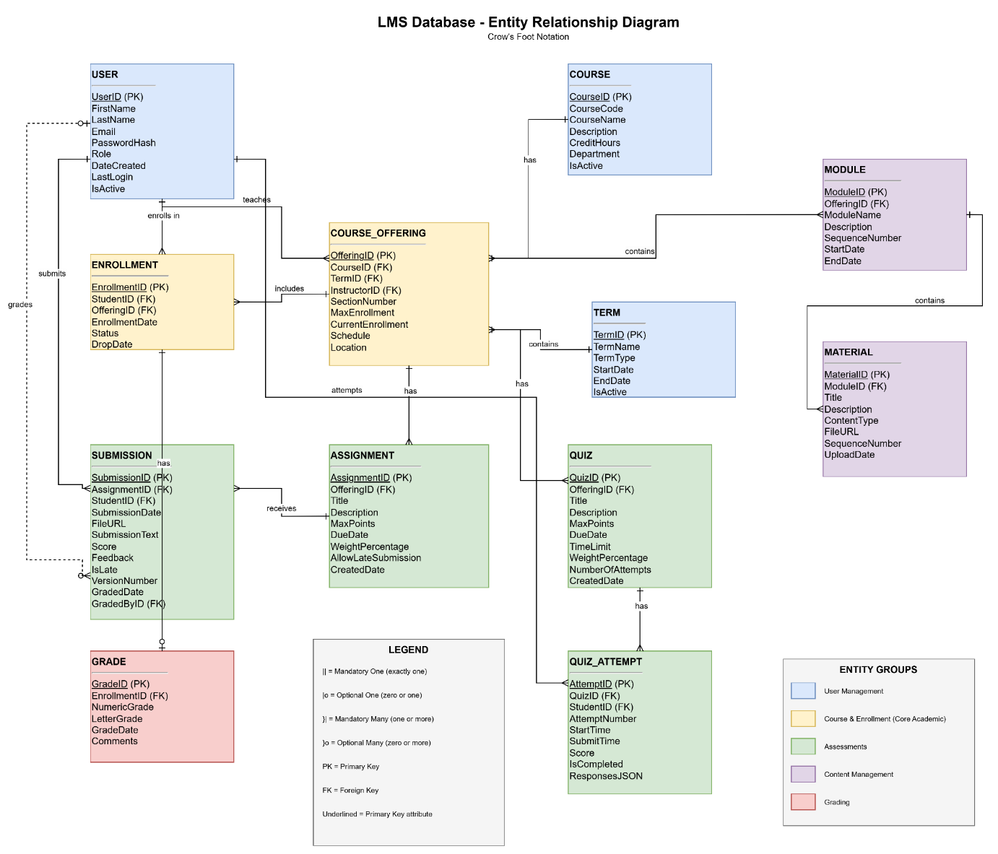

6. Data Dictionary
Entity: User
Attribute | Data Type | Length | Constraints | Description
UserID | INTEGER | - | PK, NOT NULL, AUTO_INCREMENT | Unique identifier for each user
FirstName | VARCHAR | 50 | NOT NULL | User's first name
LastName | VARCHAR | 50 | NOT NULL | User's last name
Email | VARCHAR | 100 | NOT NULL, UNIQUE | User's email address (used for login)
PasswordHash | VARCHAR | 255 | NOT NULL | Encrypted password hash
Role | ENUM | - | NOT NULL | User role: 'Student', 'Instructor', 'TA', 'Admin'
DateCreated | TIMESTAMP | - | NOT NULL, DEFAULT CURRENT_TIMESTAMP | Account creation date
LastLogin | TIMESTAMP | - | NULL | Last login timestamp
IsActive | BOOLEAN | - | NOT NULL, DEFAULT TRUE | Account active status

Entity: Course
Attribute | Data Type | Length | Constraints | Description
CourseID | INTEGER | - | PK, NOT NULL, AUTO_INCREMENT | Unique identifier for each course
CourseCode | VARCHAR | 20 | NOT NULL, UNIQUE | Course code (e.g., 'INFO5707')
CourseName | VARCHAR | 200 | NOT NULL | Full course title
Description | TEXT | - | NULL | Detailed course description
CreditHours | DECIMAL | (3,1) | NOT NULL, CHECK (CreditHours > 0) | Number of credit hours
Department | VARCHAR | 100 | NOT NULL | Academic department offering course
IsActive | BOOLEAN | - | NOT NULL, DEFAULT TRUE | Course catalog active status

Entity: Term
Attribute | Data Type | Length | Constraints | Description
TermID | INTEGER | - | PK, NOT NULL, AUTO_INCREMENT | Unique identifier for each term
TermName | VARCHAR | 50 | NOT NULL, UNIQUE | Term name (e.g., 'Fall 2025')
TermType | ENUM | - | NOT NULL | Term type: 'Fall', 'Spring', 'Summer', 'Winter'
StartDate | DATE | - | NOT NULL | Term start date
EndDate | DATE | - | NOT NULL, CHECK (EndDate > StartDate) | Term end date
IsActive | BOOLEAN | - | NOT NULL, DEFAULT TRUE | Current term indicator

Entity: CourseOffering
Attribute | Data Type | Length | Constraints | Description
OfferingID | INTEGER | - | PK, NOT NULL, AUTO_INCREMENT | Unique identifier for course offering
CourseID | INTEGER | - | FK (Course), NOT NULL | Reference to course
TermID | INTEGER | - | FK (Term), NOT NULL | Reference to term
InstructorID | INTEGER | - | FK (User), NOT NULL | Reference to instructor user
SectionNumber | VARCHAR | 10 | NOT NULL | Section identifier (e.g., '001', 'A')
MaxEnrollment | INTEGER | - | NOT NULL, CHECK (MaxEnrollment > 0) | Maximum student capacity
CurrentEnrollment | INTEGER | - | NOT NULL, DEFAULT 0, CHECK (CurrentEnrollment >= 0) | Current number of enrolled students
Schedule | VARCHAR | 100 | NULL | Meeting schedule description
Location | VARCHAR | 100 | NULL | Physical or virtual location
UNIQUE (CourseID, TermID, SectionNumber) |  |  |  | Ensures unique sections per term

Entity: Enrollment
Attribute | Data Type | Length | Constraints | Description
EnrollmentID | INTEGER | - | PK, NOT NULL, AUTO_INCREMENT | Unique identifier for enrollment
StudentID | INTEGER | - | FK (User), NOT NULL | Reference to student user
OfferingID | INTEGER | - | FK (CourseOffering), NOT NULL | Reference to course offering
EnrollmentDate | TIMESTAMP | - | NOT NULL, DEFAULT CURRENT_TIMESTAMP | Date student enrolled
Status | ENUM | - | NOT NULL, DEFAULT 'Enrolled' | Status: 'Enrolled', 'Dropped', 'Completed', 'Withdrawn'
DropDate | TIMESTAMP | - | NULL | Date enrollment was dropped (if applicable)
UNIQUE (StudentID, OfferingID) |  |  |  | Prevents duplicate enrollments

Entity: Assignment
Attribute | Data Type | Length | Constraints | Description
AssignmentID | INTEGER | - | PK, NOT NULL, AUTO_INCREMENT | Unique identifier for assignment
OfferingID | INTEGER | - | FK (CourseOffering), NOT NULL | Reference to course offering
Title | VARCHAR | 200 | NOT NULL | Assignment title
Description | TEXT | - | NULL | Detailed assignment instructions
MaxPoints | DECIMAL | (5,2) | NOT NULL, CHECK (MaxPoints > 0) | Maximum possible points
DueDate | TIMESTAMP | - | NOT NULL | Assignment due date and time
WeightPercentage | DECIMAL | (5,2) | NOT NULL, CHECK (WeightPercentage >= 0 AND WeightPercentage <= 100) | Weight toward final grade
AllowLateSubmission | BOOLEAN | - | NOT NULL, DEFAULT TRUE | Allow submissions after due date
CreatedDate | TIMESTAMP | - | NOT NULL, DEFAULT CURRENT_TIMESTAMP | Assignment creation date

Entity: Submission
Attribute | Data Type | Length | Constraints | Description
SubmissionID | INTEGER | - | PK, NOT NULL, AUTO_INCREMENT | Unique identifier for submission
AssignmentID | INTEGER | - | FK (Assignment), NOT NULL | Reference to assignment
StudentID | INTEGER | - | FK (User), NOT NULL | Reference to student user
SubmissionDate | TIMESTAMP | - | NOT NULL, DEFAULT CURRENT_TIMESTAMP | Submission timestamp
FileURL | VARCHAR | 500 | NULL | URL/path to submitted file
SubmissionText | TEXT | - | NULL | Text submission content
Score | DECIMAL | (5,2) | NULL, CHECK (Score >= 0) | Points earned
Feedback | TEXT | - | NULL | Instructor feedback
IsLate | BOOLEAN | - | NOT NULL, DEFAULT FALSE | Late submission indicator
VersionNumber | INTEGER | - | NOT NULL, DEFAULT 1 | Submission version number
GradedDate | TIMESTAMP | - | NULL | Date submission was graded
GradedByID | INTEGER | - | FK (User), NULL | Reference to grader (instructor/TA)

Entity: Quiz
Attribute | Data Type | Length | Constraints | Description
QuizID | INTEGER | - | PK, NOT NULL, AUTO_INCREMENT | Unique identifier for quiz
OfferingID | INTEGER | - | FK (CourseOffering), NOT NULL | Reference to course offering
Title | VARCHAR | 200 | NOT NULL | Quiz title
Description | TEXT | - | NULL | Quiz instructions
MaxPoints | DECIMAL | (5,2) | NOT NULL, CHECK (MaxPoints > 0) | Maximum possible points
DueDate | TIMESTAMP | - | NOT NULL | Quiz due date and time
TimeLimit | INTEGER | - | NULL, CHECK (TimeLimit > 0) | Time limit in minutes (NULL = unlimited)
WeightPercentage | DECIMAL | (5,2) | NOT NULL, CHECK (WeightPercentage >= 0 AND WeightPercentage <= 100) | Weight toward final grade
NumberOfAttempts | INTEGER | - | NOT NULL, DEFAULT 1, CHECK (NumberOfAttempts > 0) | Allowed number of attempts
CreatedDate | TIMESTAMP | - | NOT NULL, DEFAULT CURRENT_TIMESTAMP | Quiz creation date

Entity: QuizAttempt
Attribute | Data Type | Length | Constraints | Description
AttemptID | INTEGER | - | PK, NOT NULL, AUTO_INCREMENT | Unique identifier for quiz attempt
QuizID | INTEGER | - | FK (Quiz), NOT NULL | Reference to quiz
StudentID | INTEGER | - | FK (User), NOT NULL | Reference to student user
AttemptNumber | INTEGER | - | NOT NULL, CHECK (AttemptNumber > 0) | Attempt number for this student
StartTime | TIMESTAMP | - | NOT NULL | When student started quiz
SubmitTime | TIMESTAMP | - | NULL | When student submitted quiz
Score | DECIMAL | (5,2) | NULL, CHECK (Score >= 0) | Points earned
IsCompleted | BOOLEAN | - | NOT NULL, DEFAULT FALSE | Quiz completion status
ResponsesJSON | JSON | - | NULL | Student responses to questions
UNIQUE (QuizID, StudentID, AttemptNumber) |  |  |  | Ensures unique attempt numbers per student

Entity: Module
Attribute | Data Type | Length | Constraints | Description
ModuleID | INTEGER | - | PK, NOT NULL, AUTO_INCREMENT | Unique identifier for module
OfferingID | INTEGER | - | FK (CourseOffering), NOT NULL | Reference to course offering
ModuleName | VARCHAR | 200 | NOT NULL | Module title
Description | TEXT | - | NULL | Module description
SequenceNumber | INTEGER | - | NOT NULL, CHECK (SequenceNumber > 0) | Module order within course
StartDate | DATE | - | NULL | Module availability start date
EndDate | DATE | - | NULL | Module availability end date
UNIQUE (OfferingID, SequenceNumber) |  |  |  | Ensures unique sequence numbers per offering
Entity: Material
Attribute | Data Type | Length | Constraints | Description
MaterialID | INTEGER | - | PK, NOT NULL, AUTO_INCREMENT | Unique identifier for material
ModuleID | INTEGER | - | FK (Module), NOT NULL | Reference to module
Title | VARCHAR | 200 | NOT NULL | Material title
Description | TEXT | - | NULL | Material description
ContentType | ENUM | - | NOT NULL | Type: 'Document', 'Video', 'Link', 'PDF', 'Image'
FileURL | VARCHAR | 500 | NULL | URL/path to file or link
SequenceNumber | INTEGER | - | NOT NULL, CHECK (SequenceNumber > 0) | Material order within module
UploadDate | TIMESTAMP | - | NOT NULL, DEFAULT CURRENT_TIMESTAMP | Date material was added
UNIQUE (ModuleID, SequenceNumber) |  |  |  | Ensures unique sequence numbers per module

Entity: Grade
Attribute | Data Type | Length | Constraints | Description
GradeID | INTEGER | - | PK, NOT NULL, AUTO_INCREMENT | Unique identifier for grade record
EnrollmentID | INTEGER | - | FK (Enrollment), NOT NULL, UNIQUE | Reference to enrollment (one grade per enrollment)
NumericGrade | DECIMAL | (5,2) | NULL, CHECK (NumericGrade >= 0 AND NumericGrade <= 100) | Calculated numeric grade
LetterGrade | VARCHAR | 5 | NULL | Letter grade (A, A-, B+, etc.)
GradeDate | TIMESTAMP | - | NULL | Date grade was finalized
Comments | TEXT | - | NULL | Additional comments from instructor

7. AI Use Disclosure Statement
AI Tools Used
Tool Name: Gemini
Version/Model: 2.5 Flash
Purpose of AI Usage
The following were the specific purposes of using AI assistance in the development of this Design Phase Report:
- Document Structure and Formatting: Gemini assisted in structuring the report sections in a logical order and make a professional presentation keeping in mind the academic standards.
- Business Rules Refinement: Gemini helped to formulate the business rules in the specific language allowing them to be clear and comprehensive.
- User Requirements Expansion: Gemini was applied to expand short requirement notes into full-fledged well-formatted requirement statements.
- Grammar and Clarity: It also offered the recommendations on how to improve sentence and technical writing structure.
Human Contributions
The team members worked on all core intellectual content:
- Database design and entity identification.
- Relationship definition and cardinality specifications.
- Organizational rules and business logic.
- Types of data and selections of constraints.
- Scope specification and functional requirements.
- ERD conceptual design
Verification
The AI-generated suggestions were all checked, confirmed, and accepted by the team members to make sure that they are accurate, relevant, and correspond to the course requirements and principles of database design.
Limitations Acknowledged
The team recognizes that human judgment cannot be substituted by the use of AI tools in determining what to include in a database design. The overall design decision is based on the knowledge the team had on the problem domain and the database normalization principles.

